THINGS TO FINALISE :

REFERECNCE AREA;

LINER LENGTH AND DIAMETER ;

INNNER COMBUSTION WALL DIAMETER

PLANNING ON MAKING THEM WITH SHEET METAL , DIMENSIONS , TO CUT , ETC .

HOLE DIAMETERS

KEY DIFFERENCES AND DESGIN CHANGES BW TURBINE LESS AND TURBINE JET ENGINES

AND INCORPORATAE IN THE DESIGN ACCORDINGLY

……………………………………………………..

AFTER A ROUGH FINALISED DESIGN ALL THE PARTS HAVE TO PLANNED ON HOW TO BE BROUGHT FROM IMAGINATION AND BRAIN TO REAL LIFE .

Energy density of fuels :

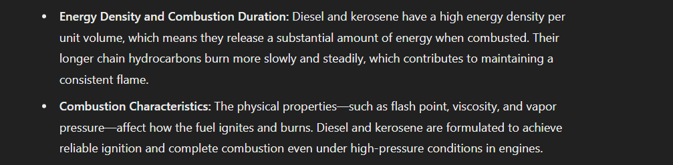



Nozzle variations

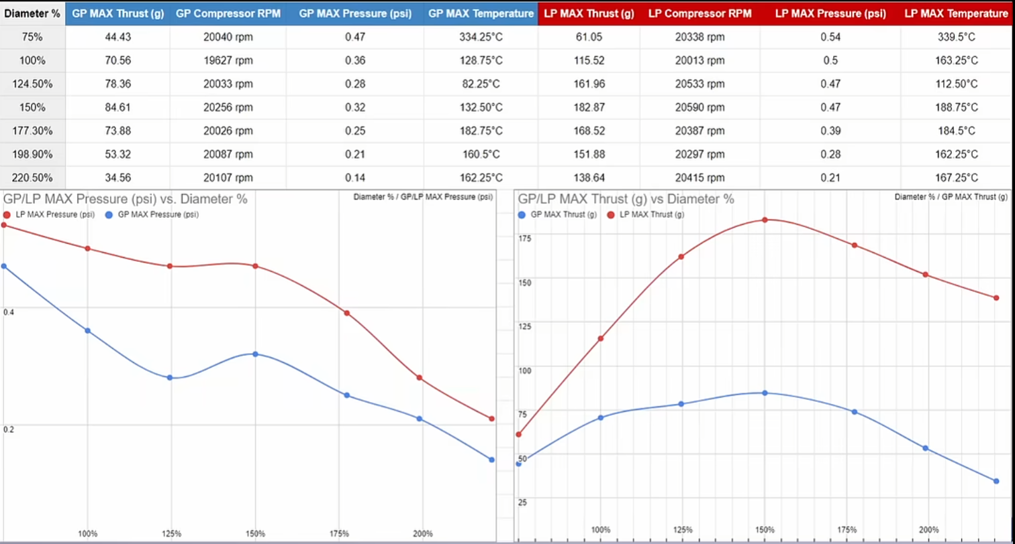

How are Russian s able to achieve a stable thrust ?

Things to buy :

1)Butane cans

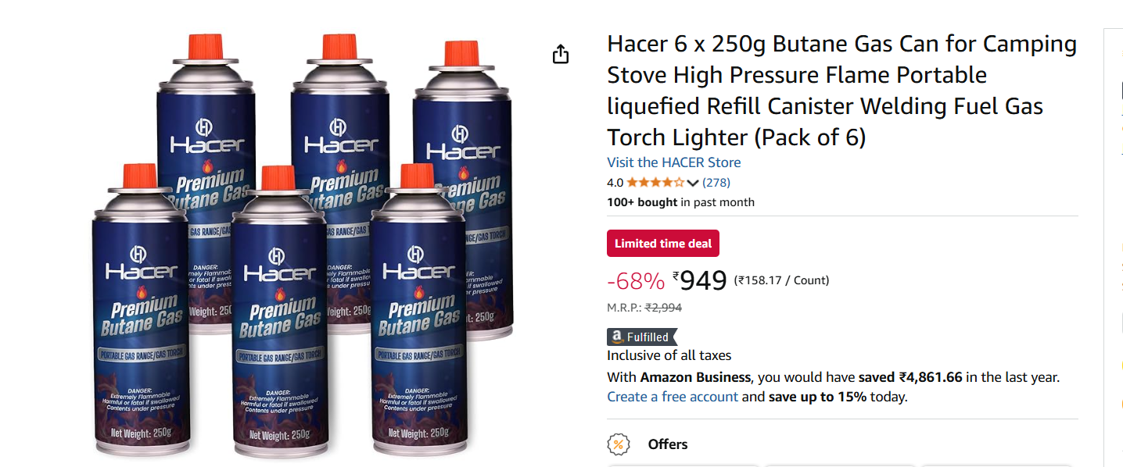

2)BRASS TORIODS , SMALL RODS

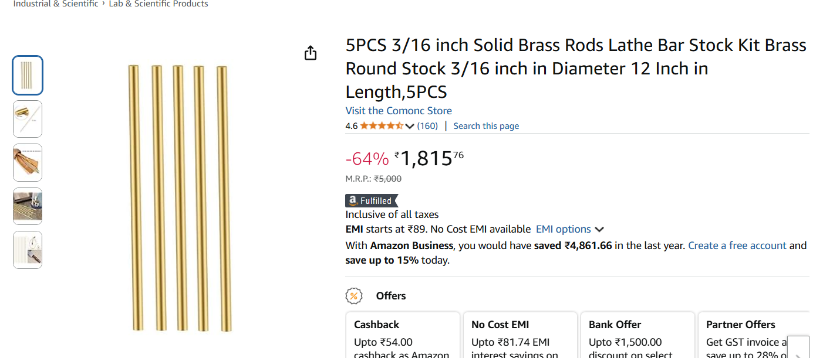

3)GLOWING CERAMIC FOR IGNITION



THINGS TO FINALISE :

REFERECNCE AREA;

LINER LENGTH AND DIAMETER ;

INNNER COMBUSTION WALL DIAMETER

HOLE DIAMETERS

KEY DIFFERENCES AND DESGIN CHANGES BW TURBINE LESS AND TURBINE JET ENGINES

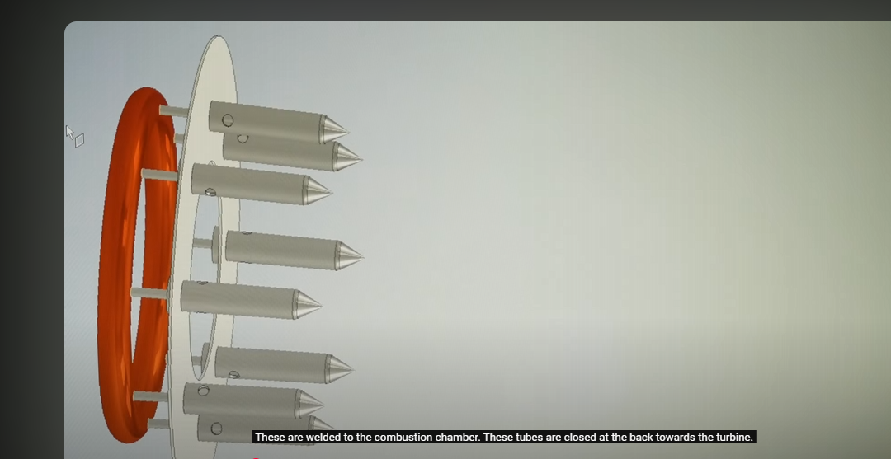

Capillary tubes closed close to turbine







A recirculation zone is a region within a flow field—such as in a jet engine’s combustion chamber—where the fluid (or gas) circulates or reverses its typical downstream direction. In combustion systems, recirculation zones are often intentionally created because they help stabilize the flame. By redirecting hot combustion products back toward the incoming fuel-air mixture, these zones promote better mixing, enhance ignition, and ensure a more uniform and efficient combustion process.

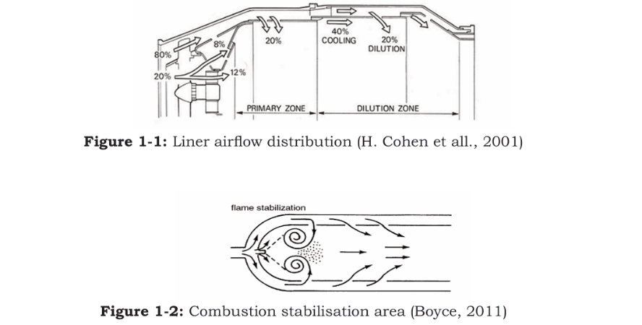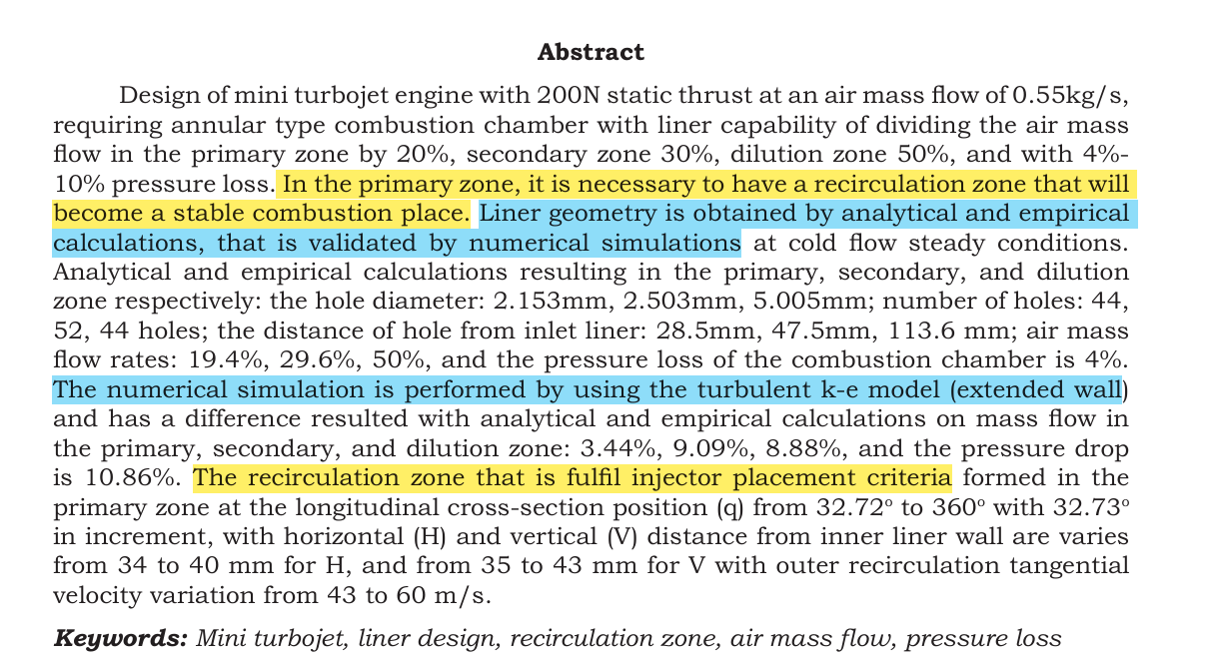

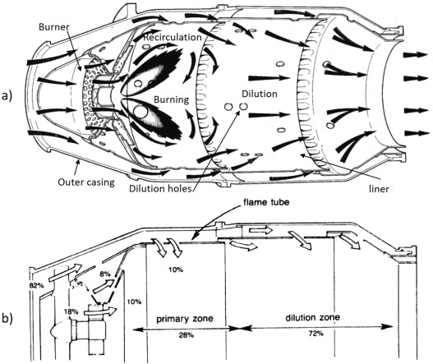

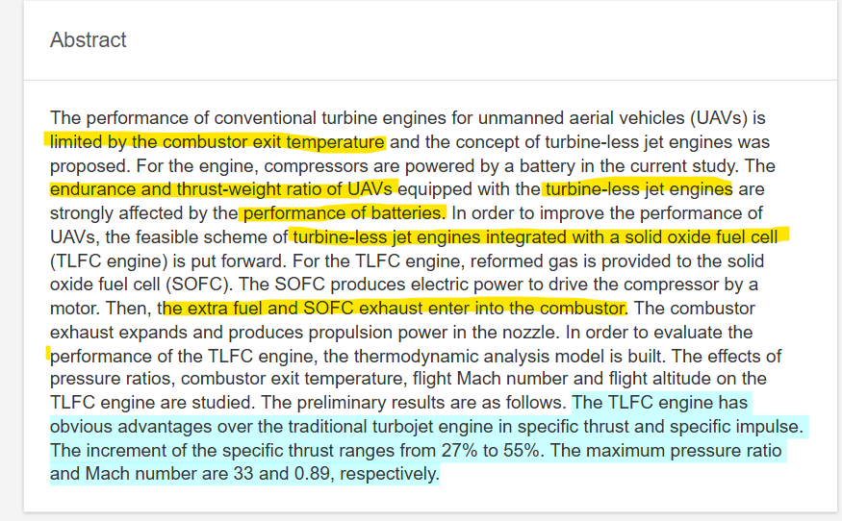

<https://www.researchgate.net/publication/334303008_Thermodynamic_Performance_Evaluation_of_a_Turbine-less_Jet_Engine_Integrated_with_Solid_Oxide_Fuel_Cells_for_Unmanned_Aerial_Vehicles>

Some appears closed to combustion chamber but they are , just vanes changing the direction of flow ,

The tube which is part of fuel injector has air fuel mixture , propelled forward by air coming from behind with pressure from in the combustion chamber ,so the fuel ring can either be in front or behind the combustion chamber .And the thin pipe form the ring is less prone for stagnation of heat as gases travel outside and away from the thin pipe .

<https://youtu.be/6RWbzGIaUG0?si=rYrALir_bcIQP8f7>

just another detailed explanation of jet engine with cad model .

4/1/25 damn its 2025

Reference cad models

<https://grabcad.com/library/kj66-turbine-combustion-chamber>

<https://grabcad.com/library/kj66-complete-turbine-engine>

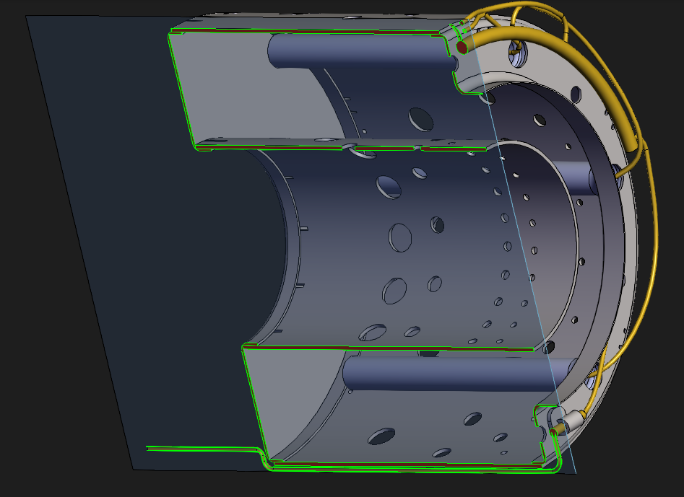

`1`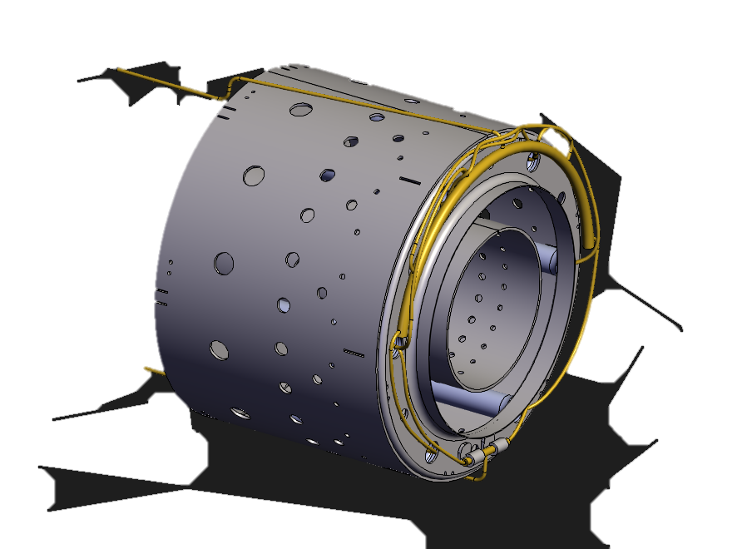

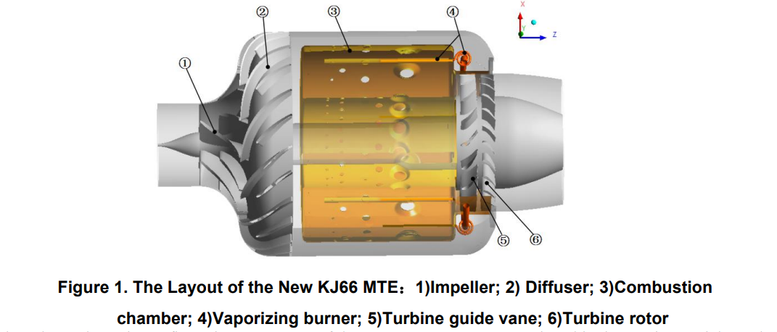

Clear picture of fuel injection

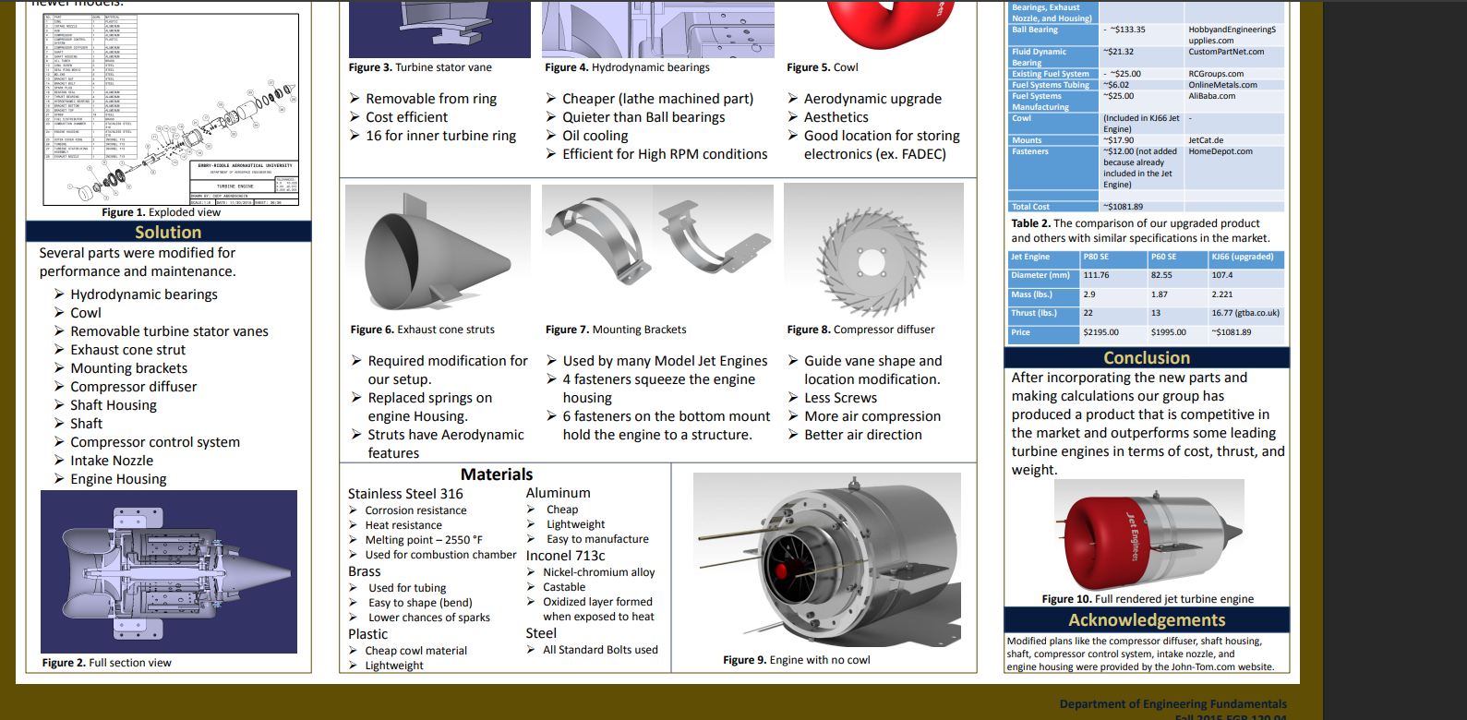materials for jet engine and for kj 66 jet engine _

<https://commons.erau.edu/cgi/viewcontent.cgi?article=1027&context=asee-edgd>

Continued above ……….)for the return mentioned in the last page(

Jet engine models 🡪 Grab cad

<https://grabcad.com/library/turbine-engine-tk-50-1>

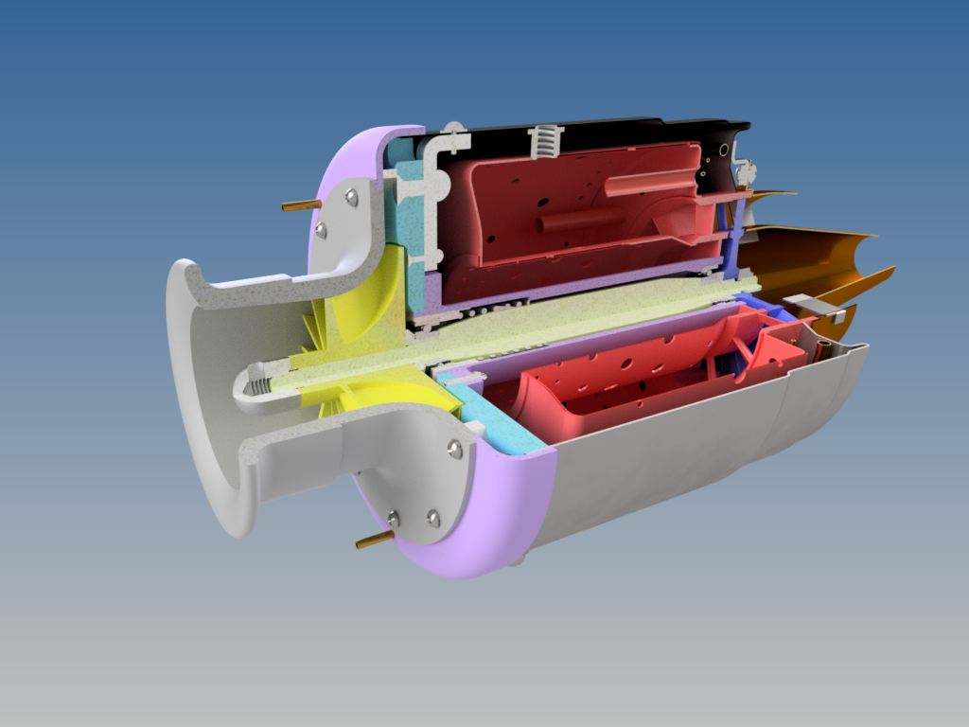 <https://grabcad.com/library/turbine-engine-kj-66-1> design 3(compresser diffuser behind and diverging nozzle to be added)

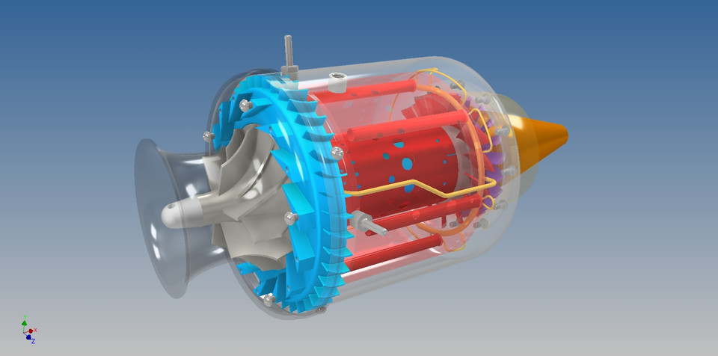

Images : (design 3 a similar oe )

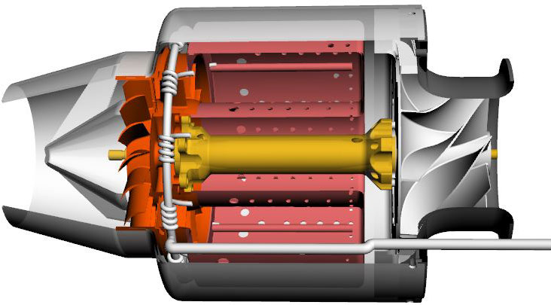

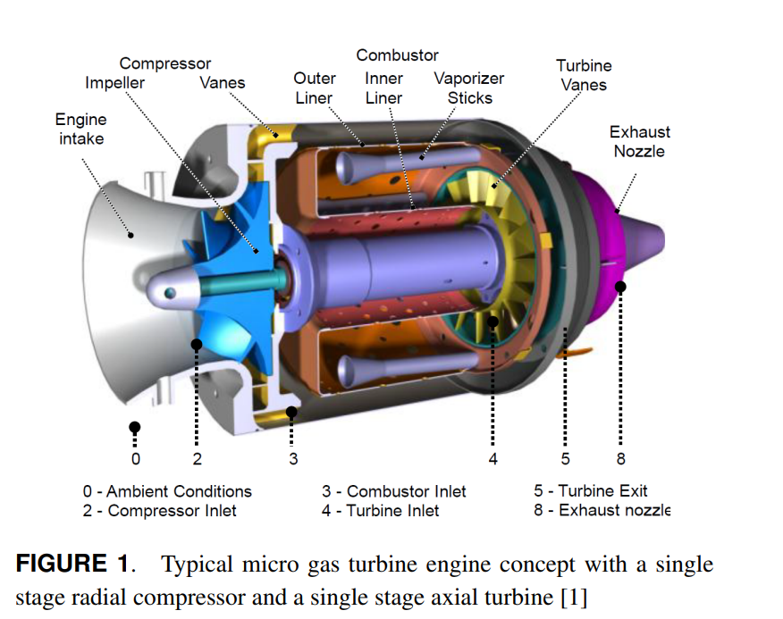Design 1 just the diverging nozzle , no holes in from of the combustion chamber .



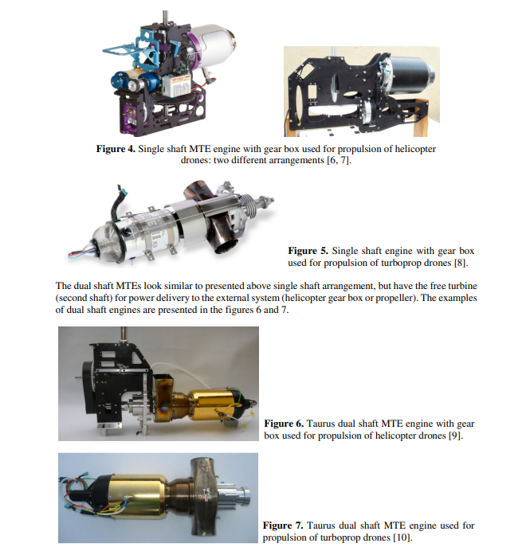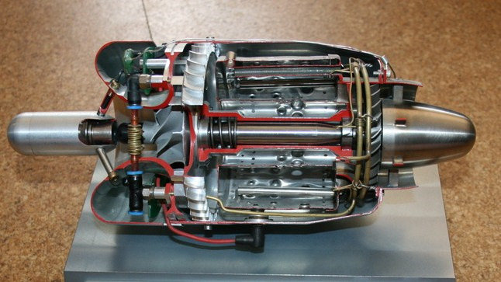  
  
using gear box

Where I am stuck is,

I finalized to use just the diffuser, and no converging behind the impeller due to several complications of it like

Disadvantages of it

increased complexity ,

decreased size and mass flow through it , etc .

I feel like there is intense heat concentration there , if I put a diffuser behind the impeller that does not seem practical ..

So instead to get the same increase in pressure , I’ll put a diffuser section behind the compressor’s diffuser and

So the order is

Impeller 🡪 Compresser Diffuser 🡪 combustion chamber diffuser

So the previously though thing is that .

I intutiveky felt that holes in front of the combustion chamber ,would be better ,

So this can be achieved through



Even we let the air passage upwards small holes can be made in front of the combustion chamber and , small gaps between the air passage can allow the air to flow into these holes ‘

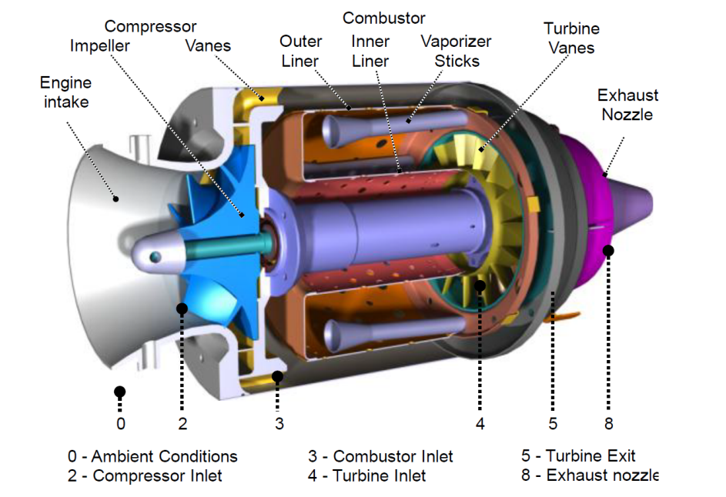

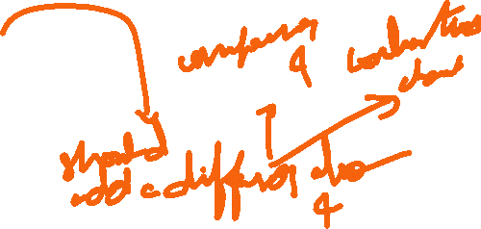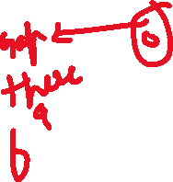

This is final chosen design

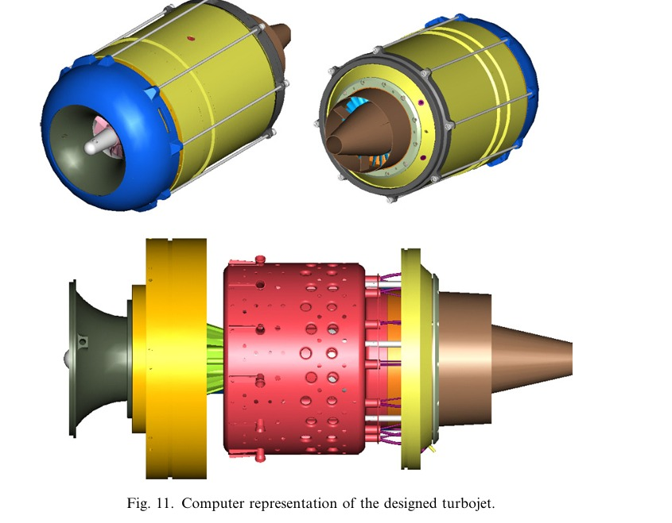

Design two using an diffuser behind the impeller and converging it behind the compressor ?

Or sort of ?

This doesn’t seem like that , it seems like the green one is just the structural connection between combustion chamber and compresser

And out of all the model I saw,

The combustion chamber has significant gap between compressor , this should be definitelyn done to prevent the heat ,

We can additionally add a diverging duct to further increase the pressure but the entire combustion chamber should be sealed to retain the pressure ,., “ O- rings to but “

And no hole in front of combustion chamber or holes with less dia , acc to design and combustion ratio ,

Maybe we need to get a simple turbine which can be cnc machined to achieve some meaningful cycle close to jet engines.

The annular diffuser just behind the compresser

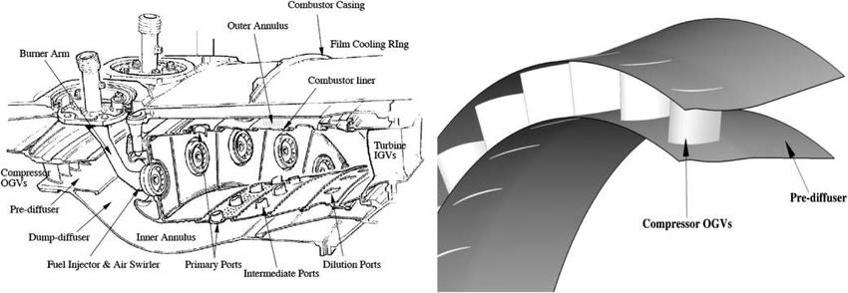

Continues at first page ……………………………………………………………………………………………..